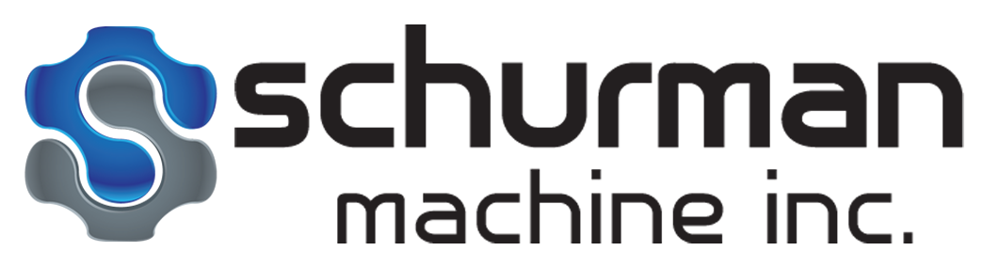
Non-Conformance / Corrective Action Report
2025-45

Customer: Vulcan Metals  PO: G21-252696  LINE: 1-16  QTY: 1 per line  PART: 1D41067-002 |  |  | Date: 11/12/2025  Operator: TYLER FARRELL, KYLE UTLEY, ALLAN NOBLE, TYLER SMITH, ANDREW ADAMS  Machine: NOMURA 2, A99  PSM JOB#: 29352-67
REWORK METHOD: NONE. PROGRAM HAS BEEN FIXED. NEW CHECKS HAVE BEEN ADDED TO THE INSPECTION ROUTE TO CONFIRM RADIUS LOCATIONAL TOLERANCES.
.
Non-conformity Detected: RADIUS GOT SHIFTED .2” FURTHER INTO THE PART.
.
Root Cause of Non-conformance: Program error, insufficient quality checks
.
Impact of all Identified Causes and the Root Cause: Radius is too far into the part.
.
Action Taken to Prevent Recurrence: NC Program has been fixed, inspection report updated to measure radius on multiple axis for location and back figured from overall height to check position from top of cap as well
.
Objective Evidence Attached: no

Affectivity Date: 11/12/2025
Name: Kyle Utley |  | Date: 11/12/2025
QA Approval: KEU | Date: 11/12/2025 |  |  | Is Follow-up Required?  YES NO
Total Rework Hours: N/A |  |  |  | Performed By:
Comments:
Meeting to be held with Vulcan to address this NCR

Print_____________________________________________________________Date_________

Sign__________________________________________________________________________

